**MINOR Project-I**

**SYNOPSIS**

**ON**

**Implementing GA for solving TSP**

**Submitted By**

|  |  |  |  |
| --- | --- | --- | --- |
| Amardeep Kumar | Rohnit Bhagat | Udit Chowdhry | Shashank Singh Karchuli |
| 500048468 | 500047663 | 500048153 | 500047009 |
|  |  |  |  |

***Under the guidance of***

**Mr. Amar Shukla**

Assistant Professor

Department of Computer Science & Engineering,



**Department of Informatics,**

**School of Computer Science and Engineering,**

**UNIVERSITY OF PETROLEUM AND ENERGY STUDIES**

**Dehradun-248007**

**2017**



**School of Computer Science and Engineering**

**University of Petroleum & Energy Studies, Dehradun**

**Project Proposal Approval Form (2017-18)**

**Minor - I**

**Project Title:**

Implementation of Genetic Algorithm using C Programming Language.

**Abstract:**

Travelling Salesman problem is a problem in combinatorial optimization (a topic that consists of finding an optimal object from a finite set of objects) studied in operational research and theoretical computer science. In our project, we will use two algorithms which are Branch and Bound algorithm and heuristic technique Genetic Algorithm for solving travelling salesman problem. The comparison between these techniques is accomplished to state which one is better for solving travelling salesman problem. Both the algorithms will be implemented to find out the optimized path and hence compare their time complexities.

**Keywords:** Travelling Salesman Problem (TSP), Branch and Bound Algorithm, Genetic Algorithm (GA), Optimized Shortest Path.

**Introduction:**

The traveling salesman problem (TSP) is the most well-known combinatorial optimization problem. TSP is to find a routing of a salesman who starts from home location, visits a prescribed set of cities and returns to the original location in such a way that the total distance travelled is minimal and each city will be visited exactly once.There are mainly two reasons for TSP being an active research area. Firstly, a large number of real world problems can be modeled by TSP. Second, it was proved to be NP-Complete problem. There are many algorithms for solving TSP but we will use Genetic Algorithm which gives the best solutions in reasonable time. It will also provide better way to solve problem in very efficient method.

**Problem Statement:-**

Travelling salesman problem states that given a number of cities N and the distance between the cities, the traveler has to travel through all the given cities exactly once and return to the same city from where he started and also the cost of the path is minimized. This path is called as the tour and the path length is the cost of the path. In a complete weighted undirected graph G (V, E), cities are represented by the vertices and the distance between the cities are represented by the edges. The travelling salesman problem has to find the minimized Hamilton cycle that starts from some specified vertex, visits all other vertices exactly once return to the same specified vertex.

**Literature Review:**

The Traveling Salesman Problem (TSP) can be solved using several techniques like Brute-Force method, Nearest Neighbor method, Branch and Bound Algorithm, Dijkstra Shortest Path Algorithm, Bellman Ford, Floyd Warshall Algorithm and some heuristic techniques like Ant Colony Optimization and Genetic Algorithm.

Out of all the mentioned above we are using Genetic Algorithm and Branch and Bound Algorithm to compare their time complexities and to get best-optimized solution.

The main focus of the Traveling Salesman Problem (TSP) is to find the shortest path to travel through the given cities and to minimize the cost. The Genetic Algorithm is applied to improve the solution for travelling salesman problem. For travelling salesman problem generating initial population means finding all possible tours for the problem.

Each chromosome represents the path travelled by the traveler. Each gene in the chromosome represents the cities to be travelled. The length of the chromosome is always the total number of cities plus one. Before applying the genetic algorithm to any problem, a method is used to represent the chromosomes or the individual solutions so that the computer can process it. This representation method is called as encoding. There are many approaches for encoding such as Binary Encoding where the sequence of 0’s and 1’s are used to represent the genes, Value Encoding where the sequence of values is used, Permutation Encoding where every chromosome is a string of numbers and Tree Encoding where every chromosome is a tree of objects or nodes. After the genetic algorithm operators are applied finally the results are converted to the required format. This process is called as Decoding.

The travelling salesman problem is used in many application areas like planning, logistics, manufacturing of microchips, DNA sequencing, vehicle routing problems, robotics, airport flight scheduling, time and job scheduling of machines. The travelling salesman problem can be classified as Symmetric Travelling Salesman Problem (STSP), Asymmetric Travelling Salesman Problem (ATSP), and Multi Travelling Salesman Problem (MTSP).

1. STSP: In STSP the distance between two cities is same in both the directions that mean this will result in an undirected graph.
2. ATSP: In ATSP the distance between two cities is not same in both directions. It is a directed graph and distance is different in both the directions.
3. MTSP: In a given set of nodes, let there be ‘m’ salesmen located at a single depot node. The remaining nodes (cities) that are to be visited are intermediate nodes. Then, the MTSP finds the tours for all ‘m’ salesmen, who all start and end at the place, such that each intermediate node (city) is visited exactly once and the total cost of visiting all nodes is minimized.

Solution of TSP may be of two types. The first will find the optimal solution, which is almost nearer to the exact solution. This will guarantee the quality of the solution, but it is very slow. The second will find the nearest optimal solution within a reasonable time. It will not guarantee that the solution is nearer to the exact solution. So to improve the solution space and to increase the performance genetic algorithms are used to solve the travelling salesman problem, which also gives the result within a reasonable amount of time.

**Objectives:**

* To find out the optimized path for Travelling Salesman Problem by applying the Genetic Algorithm and the Branch and Bound Algorithm.
* To compare the efficiency of both the algorithms in solving TSP.

**Methodology:**



* **BRANCH AND BOUND ALGORITHM:**

In Branch and Bound method, for the current node in a tree we compute a bound on best possible solution that we can get if we traverse down this node. If the bound on best possible solution itself is worse than current best (best computed so far), then we ignore the sub-tree rooted with the node.

Note that the cost through a node includes two costs.

1) Cost of reaching the node from the root (when we reach a node, we have this cost computed)  
2) Cost of reaching an answer from current node to a leaf (we compute a bound on this cost to decide whether to ignore sub-tree with this node or not).

* In cases of a **maximization problem**, an upper bound tells us the maximum possible solution if we follow the given node.
* In cases of a **minimization problem**, a lower bound tells us the minimum possible solution if we follow the given node.
* **GENETIC ALGORITHM:**

There are many methods in this algorithm for solving TSP:

1. Selection: In this, chromosomes will be selected and some individuals will be discarded. It will select the chromosomes based on the fitness value.
2. Fitness Function: It is the important parameter that defines the fitness of each individual.
3. Crossover: After the completion of the selection process, the chromosomes chosen to be parents for the next generation are recombined to form children that are new chromosomes. There are many crossover operators like Partially mapped crossover, Order crossover Single point, Two-point, Uniform and half uniform.
4. Mutation: Mutation is done after crossover. There are several ways to do mutation (Uniform, Non-Uniform, Boundary, Flip Bit, Bit String Mutation, Gaussian, Shrink,). We will do by randomly choosing a chromosome in the new generation to mutate. We randomly choose a point to mutate and switch that point.

**System Requirements:**

* Linux operating systems.
* GCC compiler.
* C Language.

**Schedule: (PERT Chart):**

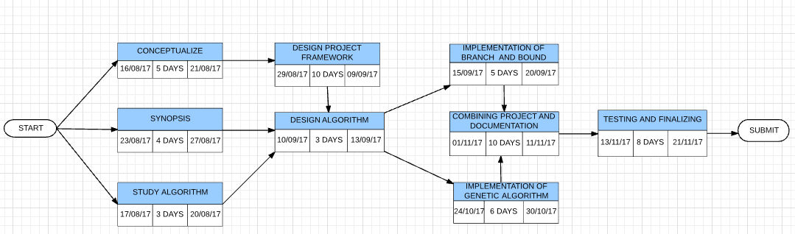

**References:**

1. Chetan Chudasama, S M Shah and Mahesh Panchal. Article: Comparison of Parents Selection Methods of Genetic Algorithm for TSP.

*COMNET-2011* 102-105, 2011.

1. S.N. Sivananadam, S.N. Deepa, Introduction to Genetic Algorithm, Springer- Verlag Berlin Heidelberg 2008.
2. CS.indstate.edu/cpothineni/alg.pdf December 13, 2013
3. https://en.wikipedia.org/wiki/Mutation_(genetic_algorithm)
4. https://en.wikipedia.org/wiki/Crossover_(genetic_algorithm)

**Approved By**

**(Name & Sign) (Name & Sign)**

**Project Guide Program Head**